**Laboratory work #8**

**Pointers and dynamic memory**

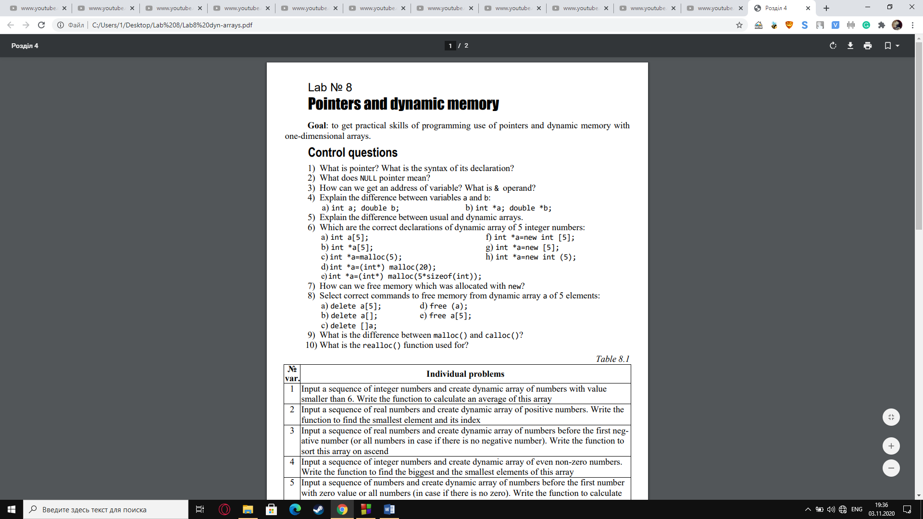**Purpose:** to get practical skills of programming use of pointers and dynamic memory with one-dimensional arrays.

**Answers on control questions**

1. A pointer variable is a variable whose value is the address of

a location in memory. To declare a pointer variable, you must specify the type of

value that the pointer will point to, for example, int *p; — a pointer to an int

2. NULL pointer is a such pointer constant, which is denoted by NULL

and called the “null pointer”.

3. & is the reference operator which we use to get the memory address of a variable.

4. a) variables, locations of which are in the computer’s memory and can be accessed by their identifier.

b) pointers which obtain the address of a variable during runtime of the program to access data.

5. A dynamic array is an array whose size is determined when the program is running, not when you write the program, what more suits for usual arrays.

6. e, f

7. We can free memory which was allocated with new using operator DELETE in such way:

delete array; - only one element will be deleted.

delete [] array; - computer will check the size and all elements will be deleted.

8. c

9. Calloc() method allocates space in memory for some elements each of them is with the size of a type.

Malloc() method is used for allocation of space in memory for a single block of memory with the special size.

10. Realloc() function is used for dynamic changing the memory allocation of a previously allocated memory if the memory previously allocated by malloc() or calloc() is insufficient.

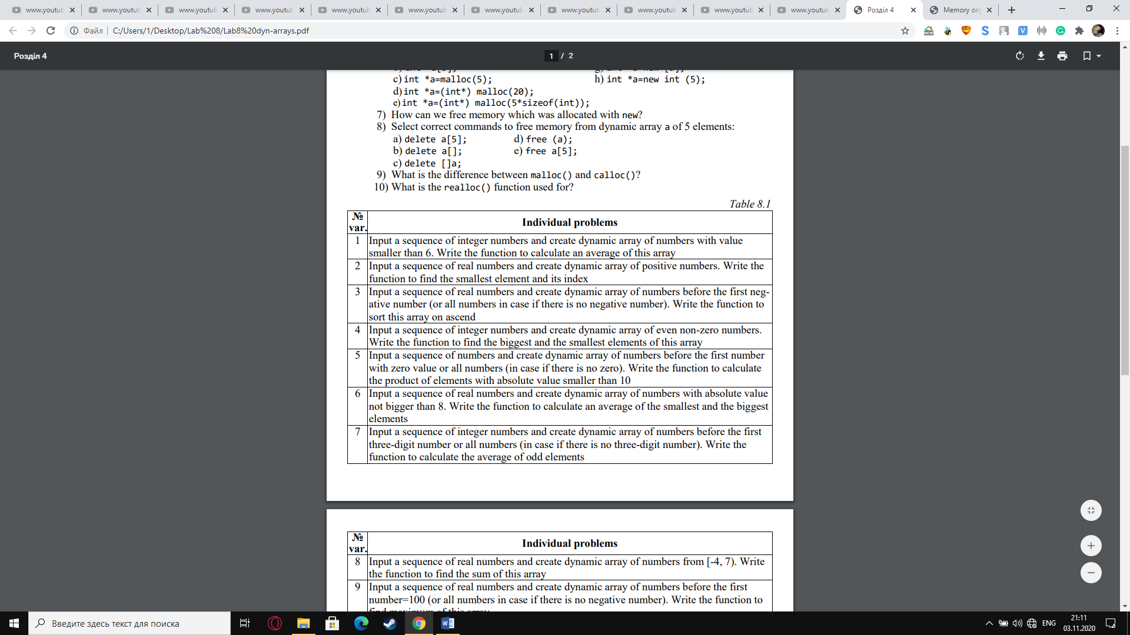

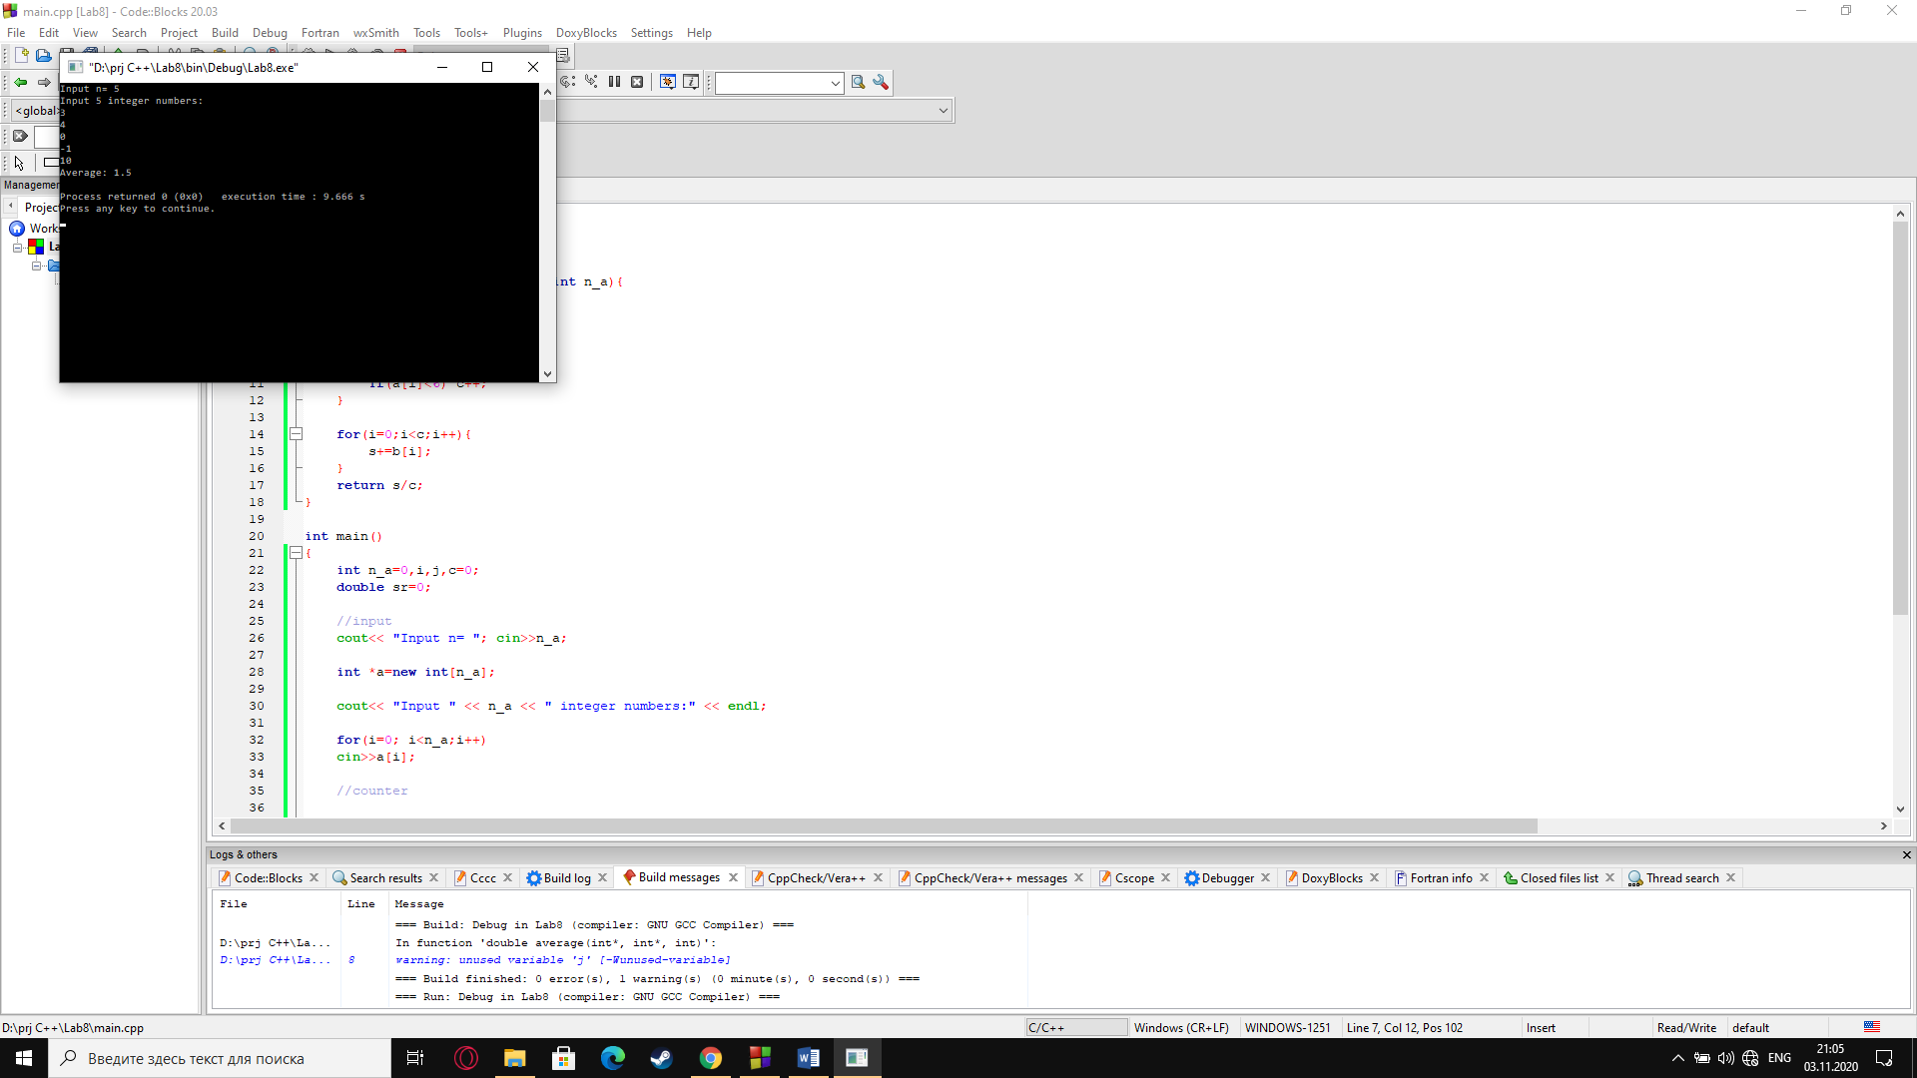

cout<< "Input n= "; cin>>n_a;

int *a=new int[n_a];

cout<< "Input " << n_a << " integer numbers:" << endl;

for(i=0; i<n_a;i++)

cin>>a[i];

int *b=new int[c];

for(i=0,j=0;i<n_a;i++,j++){

if(a[i]<6) {

b[j]=a[i];

}

}

sr=average(a,b,n_a);

cout<< "Average: " << sr << endl;

delete []a; delete []b;

return 0;

}

#include <iostream>

using namespace std;

double average(int a[],int b[],int n_a){

double c=0,s=0;

int i,j;

for(i=0;i<n_a;i++){

if(a[i]<6) c++;

}

for(i=0;i<c;i++){

s+=b[i];

}

return s/c;

}

int main()

{

int n_a=0,i,j,c=0;

double sr=0;

